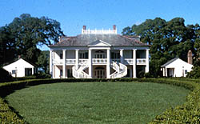
It’s hard to imagine life in antebellum Louisiana - a time of beautiful plantations and horrible slavery. In this lesson, you will look at primary sources and data from the 1800s to get a better understanding of slave life in America.

Part I: Read the information at the link Life as an Enslaved People. Use information from the site to complete items 1-9.

- Click the “Bill of Sale” link and examine the original document. What was the purpose of this document?
_______________________________________________________

- When was the document written? _________________

- Why would this kind of document have been needed?
_______________________________________________________

- What was the price of the slaves sold on this receipt? _________________

- Why would the note about Martha’s asthma have been important?
_______________________________________________________

- Click “Return to A Number of Valuable Slaves”, and then click “An Advertisement for Slaves.” Examine the original document. What was the purpose of this document?
_______________________________________________________

- When was the document written? __________________

- How many slaves were to be sold? __________________

- Why was the fact that most of the slaves were “young” an important part of the advertisement?
_______________________________________________________

_______________________________________________________

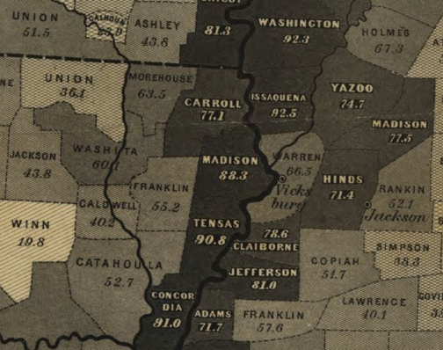
Part II: Click the link to view a special purpose map from the Library of Congress in Washington, D.C. Take a few minutes to learn how to navigate the map in order to zoom in on details and move about the map. Use the information to complete the items below.

- What was the purpose of this map?
__________________________

__________________________

__________________________

- When was the map published? __________________

- What source is given for the numbers used on the map?
_______________________________________________________

- Locate your county. What does the number on your county show?
_______________________________________________________

- According to the map legend, what does the color of your county indicate?
_______________________________________________________

- Which area of the state had the lowest percentage of slave population?
_______________________________________________________

- Which parish had the largest percentage of its people in slavery? What was that percentage?
_______________________________________________________

- A student writes “Madison Parish, LA had more slaves than Franklin Parish in 1860.” Explain why this might not be true. What other information would you need in order to know that the statement was true or false?
_______________________________________________________

_______________________________________________________

Finished Early? Check out some interesting primary sources at these links:
African American Odyssey Slave Census

